(About 900 words) – NOTE: See the bold comments as to where to place the graphics.

Google Earth
By Joe Schmitt, Member of the Tampa Bay Computer Society
jschmitt( at )tampabay.rr.com
www.tampa-bay.org

One of the greatest tools of the internet has always been that of maps. From the early days of the Internet www.mapquest.com was a great source for online geography. Now a myriad of new tools is available to home internet users to navigate through the world.

Believe it or not, one of the biggest uses for online maps is not for that big long trip to the Grand Canyon with the kids but for finding local addresses. How many times recently have you used a service such as www.mapquest.com or maps.google.com to find that new restaurant or new store? While the online services available can be used to find the next route cross-country they are more often used locally.

Another popular role that current cartographic sites such as mappoint.msn.com serve is where a particular place is in relation to your current location. There are many times when we are watching the news and someplace like Jumbo, WV pops up; there is now a great new tool to let you explore the world virtually.

Google Earth(http://earth.google.com) is a new offering from Google that offers a unique spin on online cartography. While most mapping services try to offer you a straight forward approach to mapping, Google’s newest tool takes quite a different tact. Described by Google as “a globe that sits in your PC,” Google Earth offers a new perspective on mapping software. Like all its major competitors, Google Earth will allow you to find addresses, points of interest, or a driving route. What makes Google Earth different is the way in which items are displayed to the user. Google Earth has to install software on your machine, and once installed it needs an internet connection to display its images. Also be advised that Google Earth is resource intensive: it requires a fairly fast machine with 3D graphics capability.

When you first start up Google Earth you see the below image:

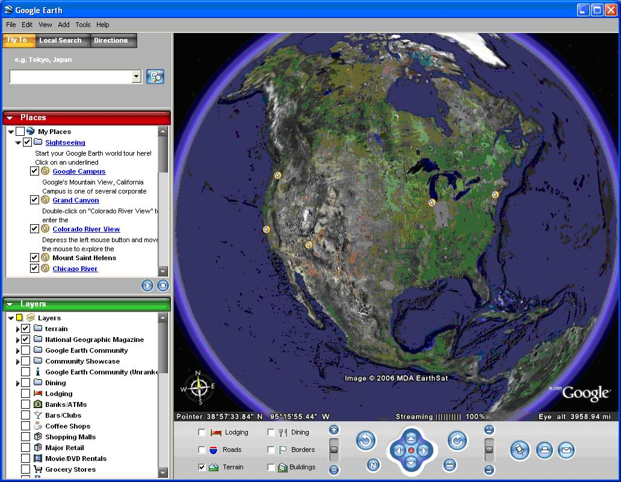

Google Earth generates an image of the planet taken from a mosaic of satellite and aerial photographs. If you enter an address such as your home in the search bar, Google Earth doesn’t just pop a map of your neighborhood but actually flies to the location. You see the image of the earth get larger and larger as if you were descending on the location from outer space. All the time as the planet moves closer, the program continually generates more detailed pictures of the surface until you are sitting above the location you are searching for.

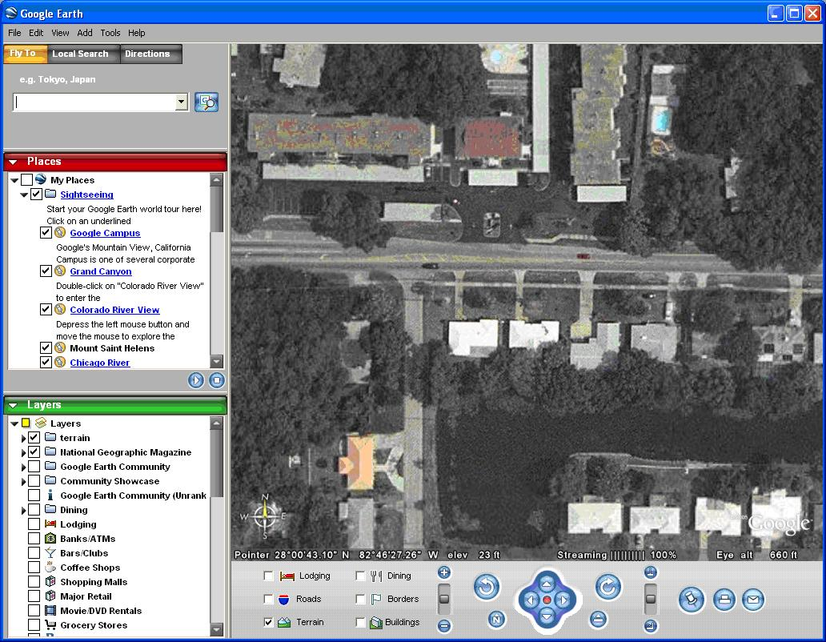

Another great feature of Google Earth is angular display. Not only are dead top center views available but you can also tilt the plane of the viewing area to see things in the distance. Now this sounds like I should be able to tilt the image and see the windows on my house, but that just isn’t possible. All the images are from satellite or aerial photographs that are also taken from straight overhead.

Topography is another feature that Google Earth incorporates makes the tilting feature quite impressive. Topography is how the terrain rises and falls in any given location. Google earth uses 3D technology to render the rise and fall of the land based on radar data gathered from multiple space shuttle missions. The images are melded with the topography and you have the impression of seeing mountains rise and canyons fall:

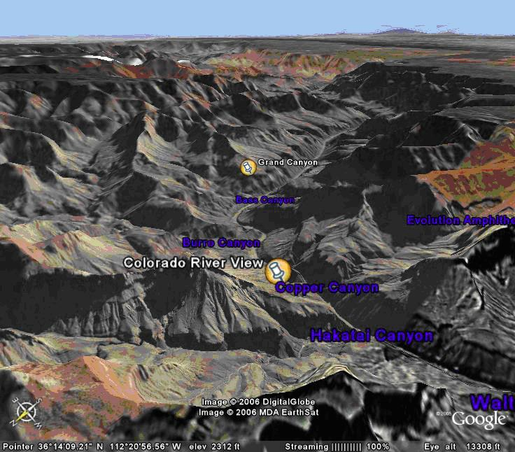

Not only does Google Earth provide these new ways to explore the world but they have also included the ability to include data files of your own. If you choose to upgrade to the “plus” version you can import data from any of the popular GPS (Global Positioning System) receivers currently available. You can import waypoints, routes, and tracks from the unit.

Also, you can import images, such as a topographic map, and orient them as overlays on the satellite images. The application will let you resize and rotate the map until fits. Google Earth will also let you save data in files that can be shared with other users. One interesting aspect is files that can utilize data available on the web for dynamic interaction. Click on this link to see some examples: http://earth.google.com/tour/thanks-win.html . For example there is a link to a file that will track flights around the US live. It displays an icon for the plane and shows it in relation to where it is in the air.

Google Earth offers some new and interesting ways to explore our world. With thousands of user files, it can be customized to any number of needs to suit your tastes. A great resource for new ideas involving Google Earth is the Google Earth blog at: http://www.gearthblog.com/ or at the community: http://bbs.keyhole.com/ubb/ubbthreads.php/Cat/0.

The only limits to Google Earth are what your imagination and determination can achieve.

Joe Schmitt is a computer and technology guru, who also has a love for the outdoors. He can often be found tromping around the woods with his GPS and digital camera.

There is no restriction against any non-profit group using this article as long as it is kept in context with proper credit given the author. The Editorial Committee of the Association of Personal Computer User Groups (APCUG), an international organization of which this group is a member, brings this article to you.

